MODELLING ILLUSTRAIONS USING GAN

A THESIS REPORT

SUBMITTED IN PARTIAL FULFILLMENT OF THE REQUIREMENTS

FOR THE AWARD OF THE DEGREE

OF

BACHELOR OF TECHNOLOGY

IN

DIVISION OF COMPUTER ENGINEERING

Submitted by:

Vaibhav Sharan (2017UCO1677)

S.M. Aadithya (2017UIT2520)

MD MEHRAN (2017UCO1651)

Under the Supervision of

Dr. Ankita Bansal

Dr. Kushil Saini



DIVISION OF COMPUTER ENGINEERING

NETAJI SUBHAS INSTITUTE OF TECHNOLOGY

UNIVERSITY OF DELHI

JUNE, 2021

**ACKNOWLEDGEMENT**

It is near impossible to work on a project without the encouragement & assistance of other people. Our project is no exception to this. We would like to express our sincere gratitude to our supervisors Prof. Ankita Bansal and Prof. Kushil Saini for providing their invaluable guidance, comments and suggestions throughout the course of the project. They were the ones who constantly motivated and encouraged us to work harder. We thank NSIT for providing us with such a good opportunity. We thank our parents, friends and family members who have always supported us. We would also give our thanks to our colleagues in directly or indirectly helping us develop the project and people who have willingly helped us out with their abilities. The project was an extremely productive & enriching experience, not only technically but also in the matter of providing some practical skills.



**Department of Computer Engieering**

University of Delhi

Delhi-110007, India

**CERTIFICATE OF ORIGINALITY**

We, Vaibhav Sharan (2017UCO1677) of B.Tech Department of Computer Enginerring, S.M. Aadithya (2017UIT2520), Md Mehran (2017UCO1651) of B.Tech, Department of Information Technology. Hereby declare that the Project-Thesis titled “Modelling Illustrations using GAN” which is submitted by us to the Department of Computer Engineering, Netaji Subhas Institute of Technology, Delhi (University of Delhi) in partial fulfillment of the requirement for the award of the degree of Bachelor of Technology, is original and not copied from source without proper citation. The manuscript has been subjected to plagiarism check by Tutnitin software. This work has not previously formed the basis for the award of any Degree.

Place: Delhi Vaibhav Sharan

Date: 28/06/21

S.M. Aadithya

Md Mehran



**Department of Computer Engineering**

Netaji Subhas University of Technology

Delhi-11007, India

**CERTIFICATE OF DECLARATION**

This is to certify that the work embodied in the Project-thesis titled “Modelling Illustrations using GAN” has been completed by S.M. Aadithya (2017UIT2520), Md Mehran (2017UCO1651) of B.Tech, Department of Computer Science, and Vaibhav Sharan (2017UCO1677) of B.Tech, Department of Computer Science, under the guidance of Dr. Ankita Bansal and Dr. Kushil Saini towards fulfillment of the requirements for the award of the degree of Bachelor of Technology. This work is based on original research and has not been submitted in full or in part of any other diploma or degree of any university.

Place: Delhi Dr. Ankita Bansal

Date: 28/06/21

Dr. Kushil Saini

**ABSTRACT**

Automaticl generationl ofl faciall imagesl hasl beenl welll studiedl afterl thel Generativel Adversariall Networkl (GAN)l becamel al well-knownl framework.l Ourl goall isl tol explorel thel trainingl ofl DCGANl modelsl specializedl onl anl animatedl faciall imagel dataset.l Itsl purposel isl tol automaticallyl generatel facesl ofl animatedl charactersl basedl onl thel faciall featuresl ofl thel inputl trainingl data.

Itl involvesl tasksl likel importingl thel imagel throughl imagel acquisitionl tools,l analysingl andl manipulatingl thel imagel tol getl outputl inl whichl resultl canl bel alteredl imagel orl evenl al reportl thatl isl basedl onl imagel analysis.

Despitel thel breakthroughsl inl accuracyl andl speedl ofl singlel imagel super-resolutionl usingl fasterl andl deeperl CNNs,l Recentl workl hasl largelyl focusedl onl minimizingl thel meanl squaredl reconstructionl error.l Thel resultingl estimatesl havel highl peakl signal-to-noisel ratios,l butl theyl arel oftenl lackingl high-frequencyl detailsl andl arel perceptuallyl unsatisfyingl inl thel sensel thatl theyl faill tol matchl thel fidelityl expectedl atl thel higherl resolution.

Ourl aiml isl tol createl al modell which,l givenl al setl ofl inputl tags,l willl outputl al setl ofl generatedl imagesl correspondingl tol thel tags.l Wel usel bothl GANl componentsl (generatorl andl discriminatorl )l whichl willl competel andl thusl withl trainingl willl returnl al modell whichl willl bel capablel enoughl wherel thel generatorl canl generatel upsampled,l goodl qualityl imagesl froml lowl qualityl images.

**INDEX**

ACKNOWLEDGEMENT 2

CERTIFICATE 3

DECLARATION 4

ABSTRACT 5

INDEX 6

LIST OF FIGURES 8

**CHAPTER 1** 9-10

INTRODUCTION

* 1. Thesis Introduction
  2. Motivation

**CHAPTER 2** 11-18

RELATED WORK

2.1 Generative Adversarial Network

2.2 Basic Architecture

2.2.1 Adversarial Network Architecture

2.3 Components of GAN

2.3.1 Convolutional Neural Networks

2.3.2 Challenges to a CNN

2.3.3 Loss Functions

2.3.4 Activation Function

2.3.5 Backpropagration

**CHAPTER 3** 19-24

METHODOLOGY

3.1 Our Approach

3.2 Design of the model

3.3 Data set and Experimental Tools setup

**CHAPTER 4**  25-27

RESULTS AND APPLICATIONS

4.1 Results

4.2 Applications

4.3 Qualitative Analysis

REFERENCES 28

LIST OF FIGURES:

Figl 1.l A generated facial image

Figl 2.l GANl basicl principle

Figl 3.l Generatorl Modell Architecture

Figl 4.l Discriminatorl Modell Architecture

Figl 5.l CNNl Components

Figl 6.l Activationl Functions

Figl 7.l Ourl GAN’sl approach

Fig 8. Images during training (1 picture per 20 epochs)

Fig 9. Sample training images.

Fig 10. Results after 5000 epochs

# **CHAPTERl 1**

**INTRODUCTIONl**

**1.1l Thesis Introduction**

Automaticl generationl ofl faciall imagesl hasl beenl welll studiedl afterl thel Generativel Adversariall Networkl (GAN)l becamel al well-knownl framework.l Ourl goall isl tol explorel thel trainingl ofl DCGANl modelsl specializedl onl anl animatedl faciall imagel dataset.l Itsl purposel isl tol automaticallyl generatel facesl ofl animatedl charactersl basedl onl thel inputtedl faciall featurel tags.

Thell projectll consistsll ofll fourll mainll steps:

1. Reviewll andll studyll recentll worksll onll thell topic.
2. Implementll onell orll morell ofll thell solutionsll andll possiblyll comparell pre-trainedll versions.
3. Getll somell data,ll trainll andll testll thell model.
4. Improvell thell modelll andll thell datall toll getll betterll results.

**1.2l Motivation**

Automaticl generationl ofl faciall imagesl hasl beenl welll studiedl afterl thel Generativel Adversariall Network(GAN)l camel out.l Therel existsl somel attemptsl applyingl thel GANl modell tol thel probleml ofl generatingl faciall imagesl ofl animel characters,l butl nonel ofl thel existingl workl givesl al promisingl result.l Inl thisl work,l wel explorel thel trainingl ofl GANl modelsl specializedl onl anl animel faciall imagel dataset.l Wel addressl thel issuel froml bothl thel datal andl thel modell aspect,l byl collectingl al morel clean,l well-suitedl datasetl andl leveragel proper,l empiricall applicationl ofl DCGAN.l

Withl qualitativel andl quantitativel analysisl andl casel studiesl wel demonstratel thatl ourl effortsl leadl tol al stablel andl high-qualityl model.l

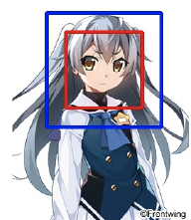

Fig 1. A generated facial image.

**CHAPTERl 2**

**RELATED WORK**

**2.1lGenerative Adversarial Network**

GANsl arel al classl ofl AIl algorithmsl basedl onl Unsupervisedl Machinel Learning.l GANsl arel deepl neurall networkl architecturesl comprisedl ofl twol networksl (Generatorl andl Discriminator)l competingl withl eachl otherl (thusl thel “adversarial”).l GANsl isl aboutl creating,l likel drawingl al portraitl orl composingl al symphony.l Thel mainl focusl forl GANsl isl tol generatel datal froml scratch.

Tol understandl GANs,l firstl wel needl tol understandl whatl al generativel modell is.l Inl machinel learning,l thel twol mainl classesl ofl modelsl arel generativel andl discriminative.l Al discriminativel modell isl onel thatl discriminatesl betweenl twol (orl more)l differentl classesl ofl data,l forl examplel al convolutionall neurall networkl thatl isl trainedl tol outputl 1l givenl anl imagel ofl al carl andl otherwisel 0.l Al generativel modell onl thel otherl handl doesn’tl knowl anythingl aboutl classesl ofl data.l Instead,l itsl purposel isl tol generatel newl datal whichl fitsl thel distributionl ofl thel trainingl data.

**2.2l Basic Architecture**

GANsl consistl ofl twol mainl componentsl whichl arel thel Generatorl andl thel Discriminator.l Thinkl itl likel al gamel wherel Generatorl triesl tol producel somel datal froml probabilityl distributionl andl Discriminatorl actsl likel al judge.l Basically,l Generatorl generatesl fakel datal whichl arel reallyl closel tol thel realisticl datal inl orderl tol fooll thel discriminator.l Whilel thel discriminatorl triesl tol learnl byl distinguishingl whichl datal isl fakel andl whichl datal isl real.

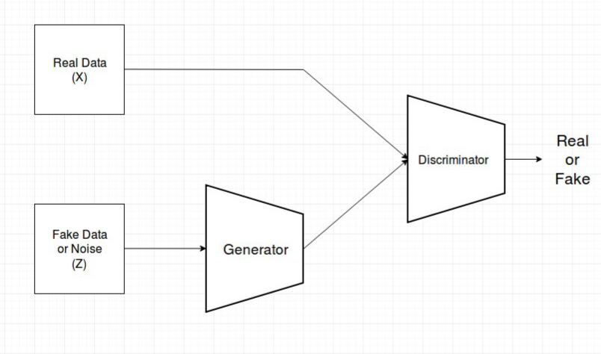

Figl 2.l GANl basicl principle

**2.2.1l Adversariall Networkl Architecture**

Thel generator’sl architecturel isl shownl inl Figurel 3,l whichl isl al modificationl froml SRResNet.l Thel modell containsl 16l ResBlocksl andl usesl 3l sub-pixell CNNl forl featurel mapl upscaling.l Figurel 4l showsl thel discriminatorl architecture,l whichl containsl 10l Resblocksl inl total.l Alll batchl normalizationl layersl arel removedl inl thel discriminator,l sincel itl wouldl bringl correlationsl withinl thel mini-batch,l whichl isl undesiredl forl thel computationl ofl thel gradientl norm.l Wel addl anl extral fully-connectedl layerl tol thel lastl convolutionl layerl asl thel attributel classifier.l Alll weightsl arel initializedl froml al Gaussianl distributionl withl meanl 0l andl standardl deviationl 0:02.

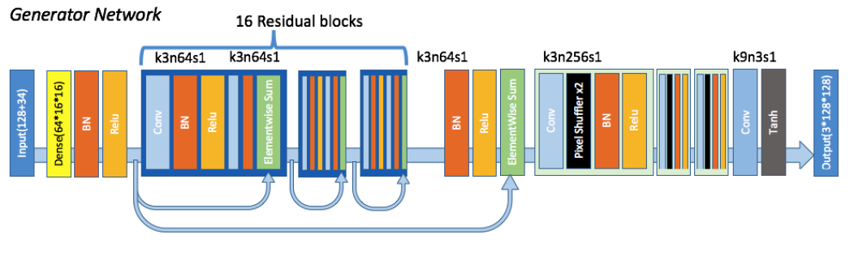

Figl 3.l Generatorl Modell Architecture

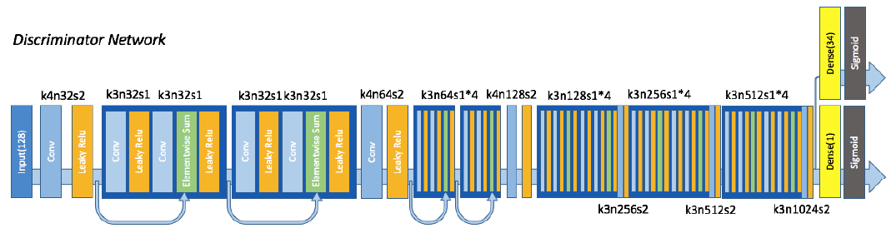

Figl 4.l Discriminatorl Modell Architecture

**2.3l Components of GAN**

Thel componentsl ofl GAN,l Generatorl andl Discriminator,l arel CNNsl (Convolutionall Neurall Networks)l asl theyl processl thel image.

**2.3.1l Convolutionall Neurall Networks**

Al Convolutionall neurall networkl (CNN)l isl al neurall networkl thatl hasl onel orl morel convolutionall layersl andl arel usedl mainlyl forl imagel processing,l classification,l segmentationl andl alsol forl otherl autol correlatedl data.l Al convolutionl isl essentiallyl slidingl al filterl overl thel input.

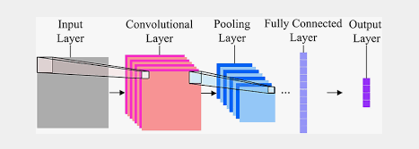

Figl 5.l CNNl Components

Thel statel ofl thel artl forl manyl computerl visionl problemsl isl meanwhilel setl byl specificallyl designedl CNNl architectures.l Itl wasl shownl thatl deeperl networkl architecturesl canl bel difficultl tol trainl butl havel thel potentiall tol substantiallyl increasel thel network’sl accuracyl asl theyl allowl modellingl mappingsl ofl veryl highl complexity.l

Tol efficientlyl trainl thesel deeperl networkl architectures,l batchl normalizationl isl oftenl usedl tol counteractl thel internall co-variatel shift.l Deeperl networkl architecturesl havel alsol beenl shownl tol increasel performancel forl image generation.

**2.3.2l Challengesl ofl al CNN**

Thel mainl challengesl forl al neurall networkl arel learningl speedl andl trainingl setl size.l Inl orderl tol generalizel well,l al neurall networkl mustl havel enoughl trainingl datal tol learnl from.l Itl alsol needsl tol bel ablel tol learnl quicklyl enoughl sol thatl itl canl adaptl tol changingl conditionsl asl itl isl deployed.

Thel otherl mainl challengel isl beingl ablel tol providel thel networkl withl sufficientl computingl powerl tol trainl itself.l Al modernl deepl neurall networkl isl al massivel parallell computation,l andl asl suchl requiresl al largel amountl ofl processingl powerl tol train.

Thel majorl challengesl ofl al neurall networkl andl deepl neurall networkl are:

1. Datal hungry:l thel modelsl tendl tol overfitl ifl youl don'tl havel al lotl ofl datal tol trainl theml on.
2. Computel hungry:l theyl tendl tol bel veryl computationallyl intensivel andl asl suchl merel mortalsl likel mel withl justl al laptopl cannotl dol much,l orl atl leastl wel cannotl tryl outl complexl statel ofl thel artl modelsl likel thel researchersl andl morel wealthyl can.l Runtimel hasl thel samel probleml thoughl notl asl pronounced.
3. Trainingl time:l evenl onl multiplel GPUsl somel modelsl takel al longl timel tol train.
4. Interpretability:l theyl havel millions,l orl evenl billionsl ofl parametersl withl ordersl ofl magnitudel morel relationshipsl betweenl saidl parameters.l Wel thereforel cannotl knowl whatl relationshipsl orl parametersl ledl tol al conclusion,l orl whyl exactlyl itl camel tol suchl al conclusion.

**2.3.3l Lossl Functions**

Thisl isl thel mostl importantl part.l Asl discussedl wel willl bel usingl Perceptuall loss.l Itl comprisesl ofl Contentl (Reconstruction)l lossl andl Adversariall loss.

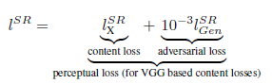

Adversariall loss:l Thisl pushesl ourl solutionl tol thel naturall imagel manifoldl usingl al discriminatorl networkl thatl isl trainedl tol differentiatel betweenl thel super-resolvedl imagesl andl originall photo-realisticl images.

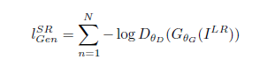

Contentl Loss:l Contentl lossl wel arel usingl sol thatl wel canl keepl perceptuall similarityl insteadl ofl pixell wisel similarity.l Thisl willl allowl usl tol recoverl photo-realisticl texturesl froml heavilyl downl sampledl images.l Insteadl ofl relyingl onl pixel-wisel lossesl wel willl andl usel al lossl functionl thatl isl closerl tol perceptuall similarity.l Wel definel thel VGGl lossl basedl onl thel ReLUl activationl layersl ofl thel per-trainedl 19l layerl VGGl network.l VGGl lossl isl definedl asl thel euclideanl distancel betweenl thel featurel representationsl ofl al reconstructedl imagel andl thel referencel image.

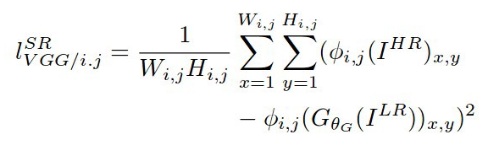

Pixel-wisel lossl functionsl suchl asl MSEl (Meanl Squarel Error)l strugglel tol handlel thel uncertaintyl inherentl inl recoveringl lostl high-frequencyl detailsl suchl asl texture:l minimizingl MSEl encouragesl findingl pixel-wisel averagesl ofl plausiblel solutionsl whichl arel typicallyl overly-smoothl andl thusl havel poorl perceptuall quality.l Reconstructionsl ofl varyingl perceptuall qualityl thel probleml ofl minimizingl MSEl wherel multiplel potentiall solutionsl withl highl texturel detailsl arel averagedl tol createl al smoothl reconstruction.

MSEl (Meanl Squarel Error)l isl thel loss/costl functionl mostl ordinarilyl usedl regressionl lossl function.l MSEl isl thatl thel suml ofl squaredl distancesl betweenl ourl targetl variablel andl predictedl valuesl Meanl squaredl errorl mayl bel al lossl functionl usedl forl regressionl oncel youl don'tl needl outliersl tol playl anl enormousl role.l Usedl asl al performancel metric,l itl isl easyl tol interpret.

**2.3.4l Activation Function**

Activationl functionsl takel anyl reall numberl asl input,l alsol knownl asl itsl domain,l andl outputsl al numberl inl al certainl rangel usingl al non-linearl differentiablel function.l Wel typicallyl usel theml forl classificationl betweenl certainl layersl inl deepl neurall networksl andl morel specificallyl inl games.

Activationl functionsl shouldl bel differentiablel andl non-linearl becausel itl isl usedl forl backpropagationl forl trainingl neurall networkl andl updatingl itsl parameters.l Itl needsl tol bel ablel tol differentiatel andl providel gradientsl tol thel previousl layer.l Itl alsol needsl tol bel non-linear.l Thel featuresl thatl arel computedl withinl thel neutrall networksl canl bel complex.l Ifl wel didn’tl usel non-linearl activations,l al neurall networkl likel thisl onel withl multiplel hiddenl layersl andl neuronsl couldl actuallyl bel collapsedl intol al simplel linearl regression.

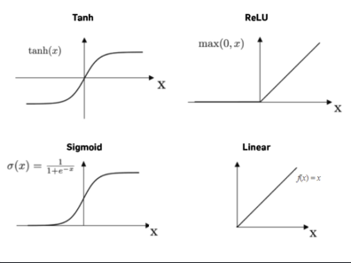

Figl 6.l Activationl Functions

**2.3.5l Backpropagation**

Backpropagationl isl al veryl commonl techniquel forl preparingl artificiall neurall organizationsl andl itl isl basedl onl anl inclinationl basedl improvementl strategy,l forl example,l stochasticl anglel plunge.l Inl backpropagation,l wel initiallyl figurel thel forecastl andl itsl relatedl lossl forl eachl preparationl model.l Atl thatl pointl wel proliferatel thel mistakel tol registerl thel fractionall subsidiariesl ofl thel costl workl Cl forl alll loadsl wl andl predispositionsl bl inl thel fakel neurall organizations.l

**CHAPTERl 3**

**METHODOLOGY**

**3.1l Our Approach**

Generativel Adversariall Networksl consistl ofl twol neurall networks:l al discriminatorl andl al generator.l Thel discriminatorl receivesl bothl reall imagesl froml thel trainingl setl andl generatedl imagesl producedl byl thel generator.l Thel discriminatorl outputsl thel probabilityl thatl anl imagel isl real,l sol itl isl trainedl tol outputl highl valuesl forl thel reall imagesl andl lowl valuesl forl thel generatedl ones.l Thel generatorl isl trainedl tol producel imagesl thatl thel discriminatorl thinksl arel real.l Bothl thel discriminatorl andl generatorl arel trainedl simultaneouslyl sol thatl theyl competel againstl eachl other.l Asl al resultl ofl this,l thel generatorl learnsl tol producel morel andl morel realisticl imagesl asl itl trains.

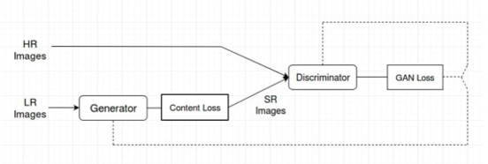

Figl 7.l Ourl GAN’sl approach

Ourl ultimatel goall isl tol trainl al generatingl functionl Gl thatl estimatesl forl al givenl setl ofl inputl tagsl al correspondingl image.l Tol achievel this,l wel trainl al generatorl networkl asl al feed-forwardl CNNl withl residuall blocks,l andl wel alsol trainl al discriminatorl networkl asl al fullyl connectedl CNNl usedl asl al classifier.

**3.2l Design of the Model**

Thel generator’sl architecturel isl shownl below,l whichl isl al modificationl froml SRResNet.l Thel modell containsl 16l ResBlocksl andl usesl 3l sub-pixell CNNl forl featurel mapl upscaling.l Thel discriminatorl architecture,l whichl containsl 10l Resblocksl inl total.l Alll batchl normalizationl layersl arel removedl inl thel discriminator,l sincel itl wouldl bringl correlationsl withinl thel mini-batch,l whichl isl undesiredl forl thel computationl ofl thel gradientl norm.l Wel addl anl extral fully-connectedl layerl tol thel lastl convolutionl layerl asl thel attributel classifier.l Alll weightsl arel initializedl froml al Gaussianl distributionl withl meanl 0l andl standardl deviationl 0:02.

**Training Model :**

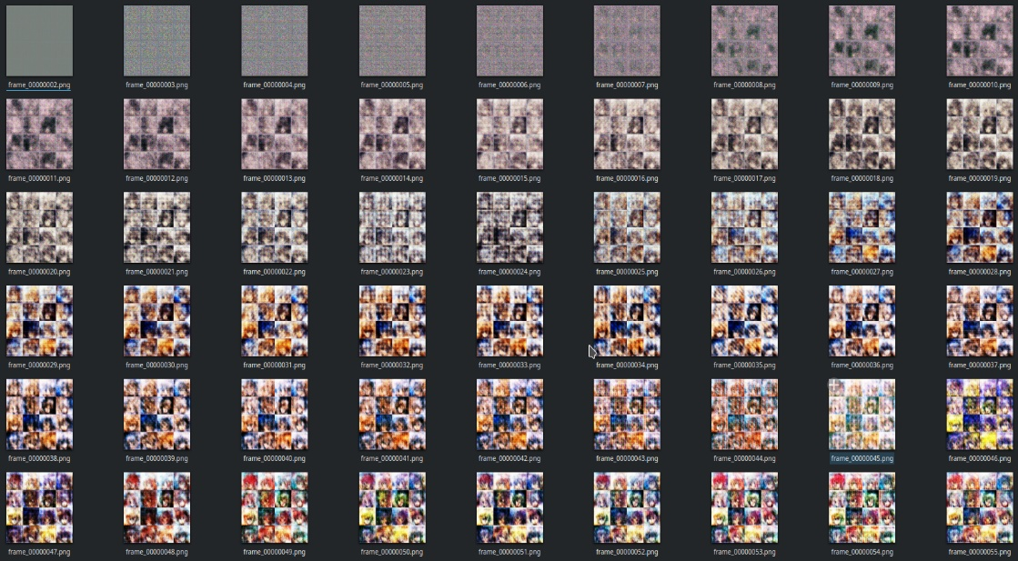

Fig 8. Images during training (1 picture per 20 epochs)

**Generator Model:**

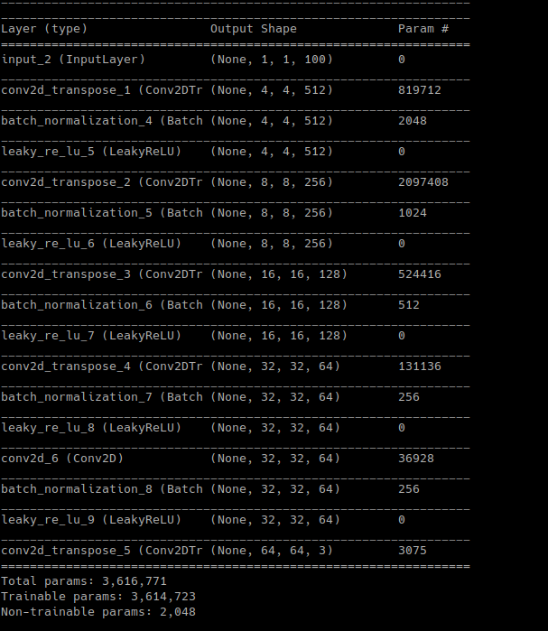

**Discriminatorl model:**

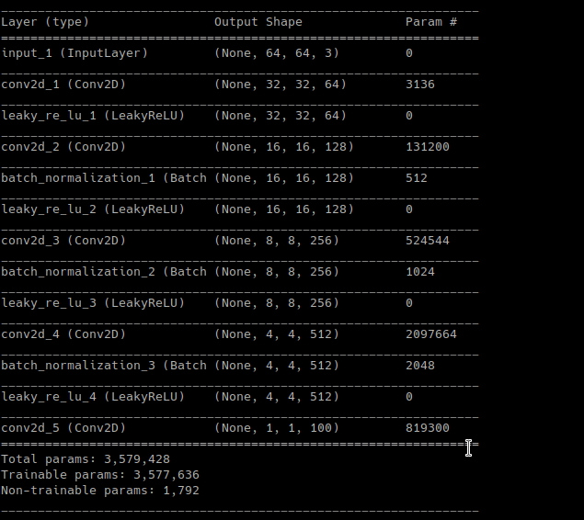

**3.3 Dats Set and Experimental Tools Setup**

anime-faces Dataset

Anime-stylel imagesl ofl 126l tagsl arel collectedl froml danbooru.donmai.usl usingl thel crawlerl tooll gallery-dl.l Thel imagesl arel thenl processedl byl al animel facel detectorl python-animeface.l Thel resultingl datasetl containsl ~143,000l animel faces.

**Experimental Tools used**

1. TensorFlow

2. Keras

3. Jupyter Notebook

4. Spyder

**Data Overview**

Itl isl welll understoodl thatl imagel datasetl inl highl qualityl isl essential,l ifl notl mostl important,l tol thel successl ofl imagel generation.l Webl servicesl hostingl imagesl suchl asl Danbooru2l andl Safebooru3,l commonlyl knownl asl imagel boards,l providel accessl tol al largel numberl ofl imagesl enoughl forl trainingl imagel generationl models.l Previousl worksl mentionedl abovel alll basel theirl approachesl onl imagesl crawledl froml onel ofl thesel imagel boards,l butl theirl datasetsl sufferl froml highl inter-imagel variancel andl noise.l l Wel hypothesizel thatl itl isl duel tol thel factl thatl imagel boardsl allowl uploadingl ofl imagesl highlyl differentl inl style,l domain,l andl quality,l andl believel thatl itl isl responsiblel forl al non-triviall portionl ofl qualityl gapsl betweenl thel generationl ofl reall peoplel facesl andl animel characterl faces.

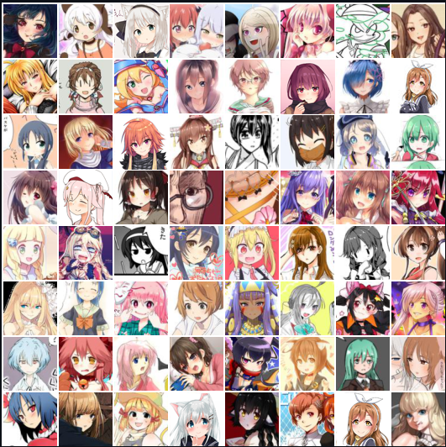

Fig 9. Sample training images.

**CHAPTER 4**

**RESULTS AND APPLICATIONS**

**4.1 Results**

Therefore automatic generation of facial images has been achieved.

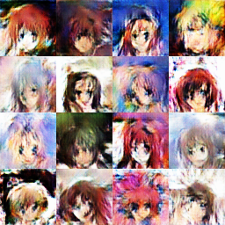

Fig 10. Results after 5000 epochs

**4.2 Applications**

Wel alll lovel animel charactersl andl arel temptedl tol createl ourl customl ones.l However,l itl takesl tremendousl effortsl tol masterl thel skilll ofl drawing,l afterl whichl wel arel firstl capablel ofl designingl ourl ownl characters.l Tol bridgel thisl gap,l thel automaticl generationl ofl animel charactersl offersl anl opportunityl tol bringl al customl characterl intol existencel withoutl professionall skill.l Besidesl thel benefitsl forl al non-specialist,l al professionall creatorl mayl takel advantagesl ofl thel automaticl generationl forl inspirationl onl animationl andl gamel characterl design;l al RPGl developerl mayl employl copyright-freel faciall imagesl tol reducel designingl costsl inl gamel production.

**4.3 Qualitative Analysis**

**Attribute Precision**

Tol evaluatel howl eachl tagl affectsl thel outputl result,l wel measurel thel precisionl ofl thel outputl resultl whenl thel certainl labell isl assigned.l Withl eachl target,l wel fixl thel targetl labell tol true,l andl samplel otherl labelsl inl random.l Forl eachl label,l 20l imagesl arel drawnl froml thel generator.l Thenl wel manuallyl checkl generatedl resultsl andl judgel whetherl outputl imagesl behavel thel fixedl attributel wel assigned.

**FIDl Evaluation**

Onel possiblel quantitativel evaluationl methodl forl GANl modell isl Fréchetl Inceptionl Distance(FID).l Tol calculatel thel FID,l theyl usel al pre-trainedl CNN(Inceptionl model)l tol extractl vision-relevantl featuresl froml bothl reall andl fakel samples.l Thel reall featurel distributionl andl thel fakel featurel distributionl arel approximatedl withl twol guassianl distributions.l Then,l theyl calculatel Thel Fréchetl distance(Wasserstein-2l distance)l betweenl twol guassianl distributionsl andl servel thel resultsl asl al measurementl ofl thel modell quality.l Thel Inceptionl modell trainedl onl ImageNetl isl notl suitablel forl extractingl featuresl ofl anime-stylel illustrations,l sincel therel isl nol suchl imagesl inl thel originall trainingl dataset.l Here,l wel replacel thel modell withl Illustration2vecl featurel extractorl modell forl betterl measurementl ofl visuall similaritiesl betweenl generatedl imagesl andl reall images.

Tol evaluatel thel FIDl scorel forl ourl model,l wel samplel 12800l imagesl froml reall dataset,l thenl generatel al fakel samplel byl usingl thel correspondingl conditionsl forl eachl samplesl reall images.l Afterl thatl wel feedl alll imagesl tol thel Illustation2vecl featurel extractorl andl getl al 4096-dimensionl featurel vectorl forl eachl image.l FIDl isl calculatedl betweenl thel collectionl ofl featurel vectorsl froml reall samplesl andl thatl froml fakel samples.

**REFERENCES**

1. C. Dong, C. C. Loy, K. He, and X. Tang. Image super-resolution using deep convolutional networks. IEEE Transactions on Pattern Analysis and Machine Intelligence, 38(2):295–307, 2016.
2. J. Johnson, A. Alahi, and F. Li. Perceptual losses for real-time style transfer and super- resolution. In European Conference on Computer Vision (ECCV), pages 694–711. Springer, 2016
3. W. Shi, J. Caballero, F. Huszar, J. Totz, A. P. Aitken, R. Bishop, D. Rueckert, and Z. Wang. Real-Time Single Image and Video Super-Resolution Using an Efficient Sub-Pixel Convolutional Neural Network. In IEEE Conference on Computer Vision and Pattern Recognition (CVPR), pages 1874–1883, 2016.
4. Yanghua Jin, Jiakai Zhang, Towards the Automatic Anime Characters Creation with Generative Adversarial Networks arXiv:1708.05509v1
5. https://github.com/tdrussell/IllustrationGAN
6. https://github.com/pavitrakumar78/Anime-Face-GAN-Keras
7. https://github.com/jayleicn/animeGAN
8. https://github.com/forcecore/Keras-GAN-Animeface-Character

